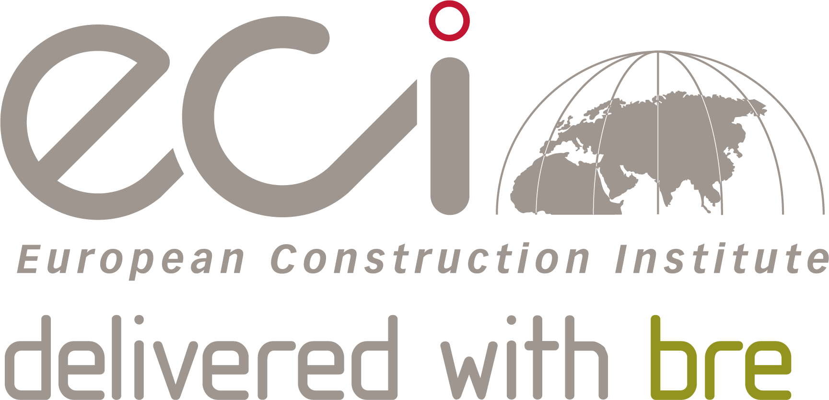
Entry Form
ECI Project of the Year

Ensure you read and understand the criteria and guidelines before completing this form. Guidelines on ‘How to Enter’ can be found at http://www.eci-online.org/eci-awards/. Importantly, please remember that:

- Information above the specified word limits will not be taken into consideration.
- Charts and photos should be embedded in the word document where possible (captions are not taken as part of the
word count). Total submission length - maximum 15 pages.
- Appendices will not be reviewed as part of the submission.
- Nominations are open to the entire industry.
- Eligible projects include those completed in the last two years.
- The award winners will be announced at the ECI's 2019 Annual Conference.

Category Description: ECI Project of the Year

- We are looking for the key principles used on your project and what you consider are the key achievements which would make your project a learning opportunity for other ECI members.
- Projects will be assessed on the extent of application of the ECI ACTIVE principles, in particular on the contribution of the ACTIVE principles to project performance.

ACTIVE stands for: Achieving Competitiveness Through Innovation and Value
Enhancement.

The eight ECI ACTIVE principles are:
1. Effective project conception and definition
2. Effective project team management
3. Effective supply chain relationships
4. Effective information management and communication
5. Effective project risk management
6. Effective innovation and continuous improvement
7. Effective project execution
8. Effective performance measurement

The ECI Awards ‘recognise the best and inspire the rest’.

What makes your submission special? We want to know if you are doing something that is new or different. Or if are you doing something that is common to the industry, but doing it better than anyone else. It could be how you manage a specific process or a wide ranging programme. It doesn’t need to be technologically cutting edge, but it does need to be exemplary.

Can you demonstrate real benefits? We want data. You needn’t submit all your information but we need to know that you have changed or achieved something through some measurable information. Did you do it cheaper, better or with increased satisfaction to your clients?
Is it honest? We are not looking for marketing information. We want real stories which give an honest summary of all the issues that you have overcome to deliver.

address the category criteria and make sure the judges understand:
Actions
What actions were taken to deliver outstanding outcomes?
Impact
What results were achieved and what evidence can you provide?
Lessons learned
What lessons have been learned through this work and how have they been shared?

Check list:
Your entry should consist of:
  - Completed entry form
  - Logos for all key parties that should be recognised in connection with any award
(original .eps files for print or JPEGS).
  - High resolution images (print quality) – up to 5 photos. Logos and images are used for publicity purposes.

Contact: +44 (0)3330 430 643 or eci@bre.co.uk

ECI Project of the Year

Entry Form

SECTION 1
Entry name
(Please keep this concise)

Applicant’s contact details | Name
 | Organisation
 | E-mail
 | Telephone
 | Address
 |  | Postcode:

Please list below all organisations that should be credited in relation to this submission.

Client
Contact name |  | E-mail:
Organisation
Contact name |  | E-mail:
Organisation
Contact |  | E-mail:
Organisation
Contact |  | E-mail:

IMPORTANT: You must provide print quality original JPEG or .eps files of all corporate logo(s).

SECTION 2: Project details
Project name
Project location
What are the project timescales or phase? |  | Start date End date
What is the project contract value?
Type of work
Type of client
Approx size in M²
SECTION 3: Your submission
Background
Describe the circumstances or challenges faced in the delivery of this project.
(maximum 250 words)
How has teamwork and collaboration touched all parties and led to a better outcome?
(maximum 250 words)
How has completion on time, budget and to specified quality been improved upon without health and safety compromises?
(maximum 250 words)
How has environmental impact been taken to lower levels?
(maximum 250 words)
How has the customer and other stakeholders reacted to your work?
(maximum 250 words)
What unique challenges were met by innovation, technical achievement and applying best practice?
(maximum 250 words)
What makes this project a winning entry? Why do you think this work stands out from the crowd and how do you suggest we share this with the industry?
(maximum 250 words)
Check list:
Your entry should consist of:
  - Completed entry form – low resolution images can be embedded in the entry form.
  - Logos for print - file format = .eps. You should include all partners listed above.
  - High resolution images (print quality)

The entry form is the only document that will be considered at this stage. Please do not include appendices.
Logos and images are used for publicity purposes.
Contact: +44 (0)3330 430 643 or eci@bre.co.uk

